**Case Study- Git Workflow Architecture (Zendriix Software)**

**Problem Statement:** You work as a Devops Architect in Zendriix Softwares. The company has been struggling to manage their product releases. The releases should happen on 25th of every month. Suggest a Git Workflow Architecture for this requirement. Simulate this workflow, by creating a pseudo code files and branches, and upload the same to your GitHub Account. As a part of solution, share the link to your GitHub repository.

Solution:

We have Git repo created for this simulation: Casestudy-GitWorkFlow-arch

Workflow architecture involves steps as follows:

1. Creating master branch
2. Creating Develop branch
3. Creating supporting branches like:
   1. Feature branch
   2. Release branch
   3. Hotfix branch

Commands used: 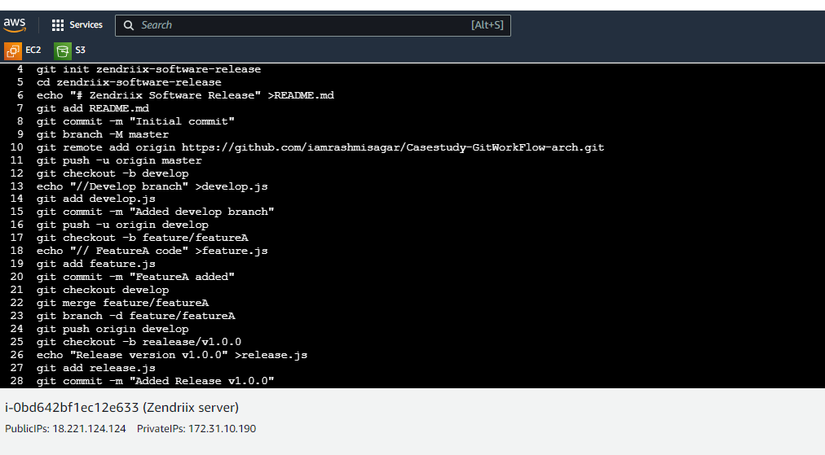

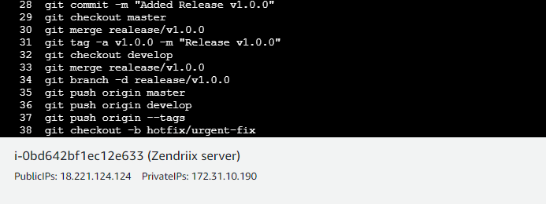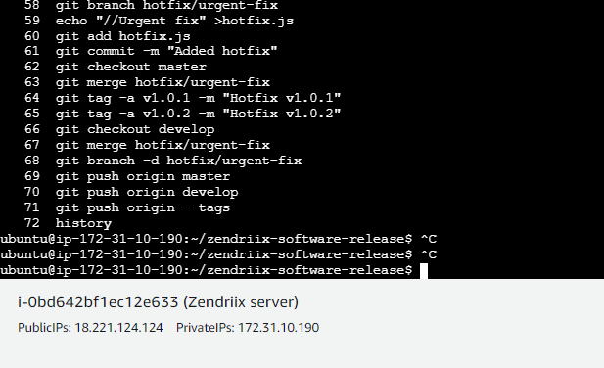

You can check the simulated workflow on this GitHub repository: <https://github.com/iamrashmisagar/Casestudy-GitWorkFlow-arch.git>